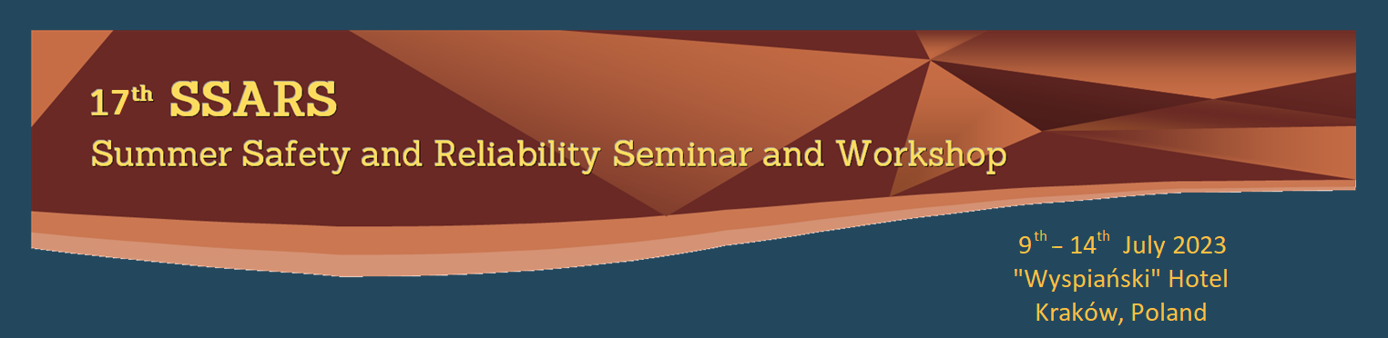

Surname: Name:

Company/Institution:

Address:

VAT ID:

Phone: E-mail:

Please, replace by where appropriate

Accommodation: Single Room Double Room (available with Accompanying Person)

Arrival Date/Time: Departure Date/Time:

(not earlier than 9th July at 14⁰⁰) (not later than 14th July at 11⁰⁰)

Accompanying Person Name:

(if applicable, accommodation in a double room with SSARS 2023 Participant)

Participant Full Seminar Fee: 600 € (2850 PLN)
...... € (PLN)
(including: sessions attendance, seminar program, monograph, 5 days accommodation
in the hotel, catering and social events)
Participant Seminar Fee (without accommodation): 400 € (1900 PLN)
...... € (PLN)
(including: sessions attendance, seminar program, monograph, 5 days catering and social events)
Accompanying Person Full Seminar Fee: 400 € (1900 PLN)
...... € (PLN)
(including: 5 days accommodation in the hotel, catering and social events)
Accompanying Person Seminar Fee (without accommodation): 200 € (950 PLN)
...... € (PLN)
...... € (PLN)
(including: 5 days catering and social events)
Publication (without attendance, with online presentation): 200 € (950 PLN)
...... € (PLN)
(including: monograph)
Additional publication: 300 € (1425 PLN)
...... € (PLN)

Total Payment………………………………………………………………………………

Foreign Participant
Payment should be made in EUR by Bank Transfer to:
Pol Tow Bezp i Niez
Account No: PL 89 1240 1242 1978 0010 0478 3287
(Bank Pekao SA)
Remark: PARTICIPANT SURNAME, SSARS 2023
Bank Swift Code: PKOPPLPW
Address: Al. Jana Pawła II 3, 81-345 Gdynia, Poland
Polish Participant
Payment should be made in PLN by Bank Transfer to:
Pol Tow Bezp i Niez
Account No: PL 74 1240 1242 1111 0010 0478 3160
(Bank Pekao SA)
Tytułem: PARTICIPANT SURNAME, SSARS 2023
Bank Swift Code: PKOPPLPW
Address: Al. Jana Pawla II 3, 81-345 Gdynia, Poland

